NAME: PRITHIKA .K ROLL NO:241901071
15.ENDPOINT SECURITY MONITORING
DATE: 22/04/2026
Aim:To learn about fundamentals, methodology, and tooling for endpoint security monitoring.
Procedure:
- Log into TryHackMe and open the Intro to Endpoint Security room.
- Study the fundamentals of endpoint security and its importance.
- Understand common threats targeting endpoints such as malware and exploits.
- Learn methodologies for monitoring and securing endpoint devices.
- Explore tools used for endpoint detection and response.
- Complete the tasks and answer the questions in the room.
- Review the summary and confirm completion.
Tasks:
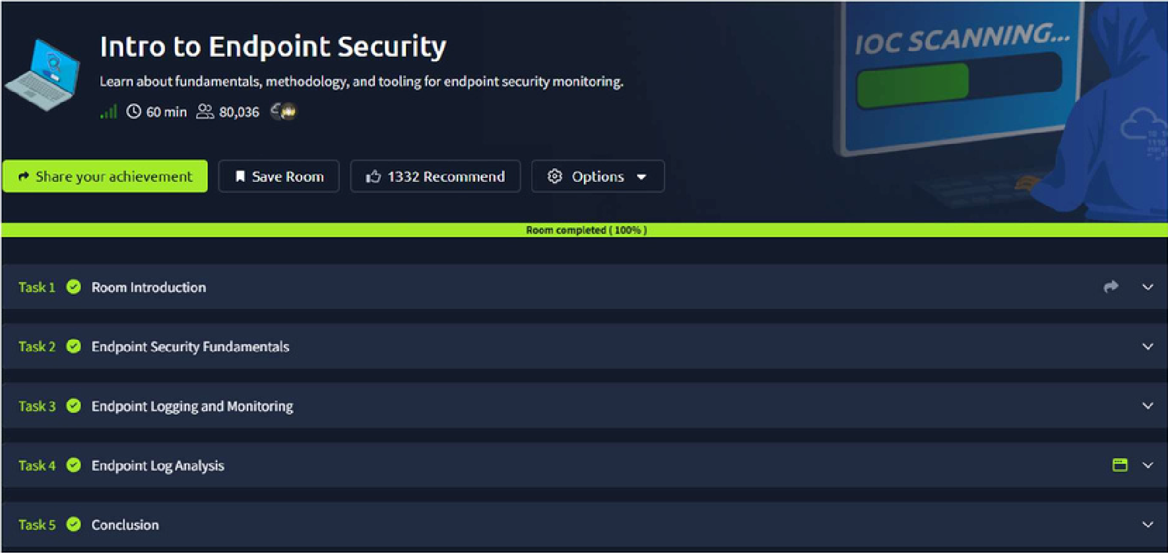
TASK 1- Room Introduction
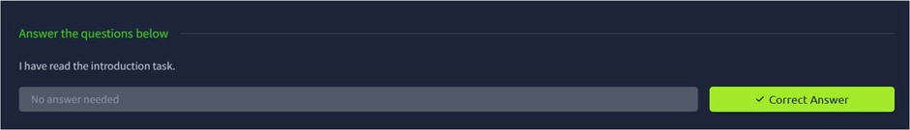
TASK 2 – Endpoint Security Fundamentals
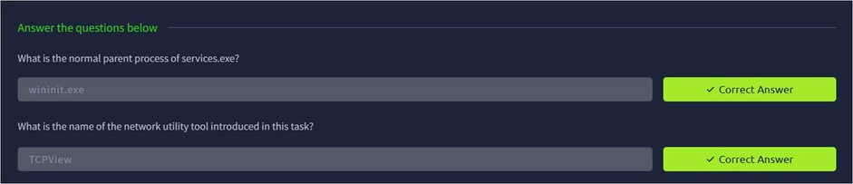

TASK 3 – Endpoint Logging and Monitoring
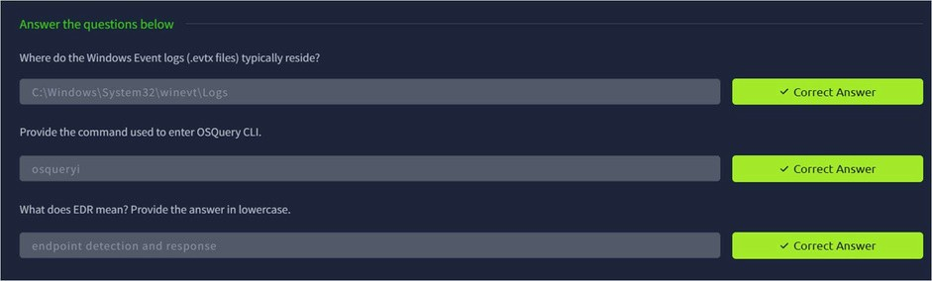
TASK 4 – Endpoint Log Analysis
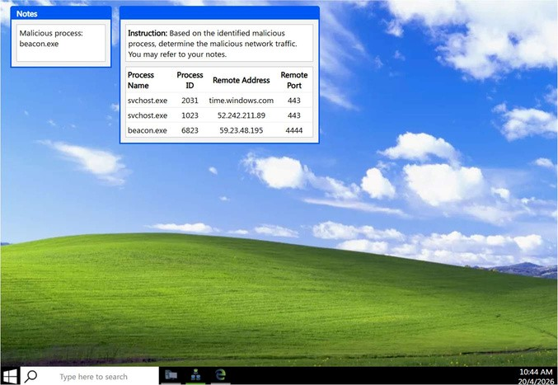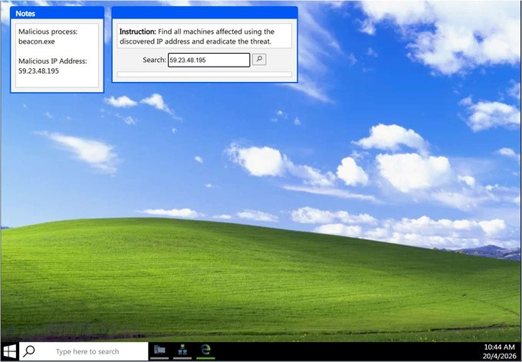

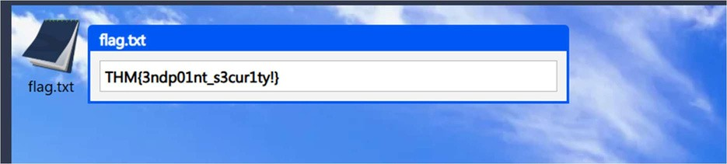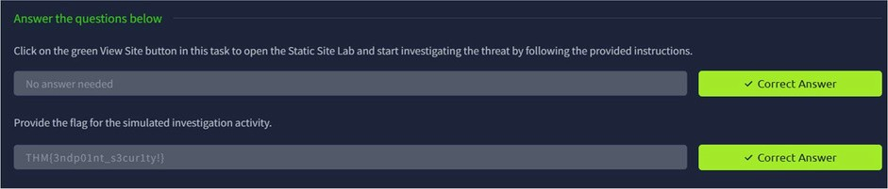
TASK 5 - Conclusion
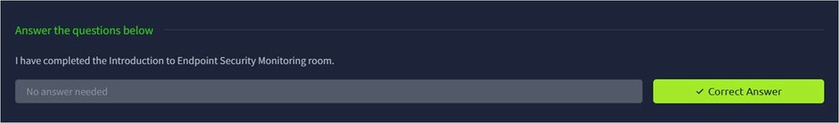
Result:
Thus the TryHackMe room “Intro to Endpoint Security” was completed successfully.

